See Employer Profiles
- Open a recommended web browser* on your computer or mobile device.
  - Apple Safari
  - Google Chrome
  - Microsoft Edge
  - Mozilla Firefox
- Enter www.careerforcemn.com in the browser address (URL) bar.
- From the CareerForceMN.com home page, scroll down to the bottom and click the “See Employer Profiles” link.
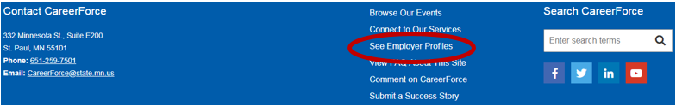
- In the “Keyword” field, enter a keyword or the organization name, if you know it.
- In the “From” field, enter a city or zip code. From the suggested matches, click the desired city or zip code.
- Click the “Less Than” drop-down menu to select the search radius.
- Click “Apply.”
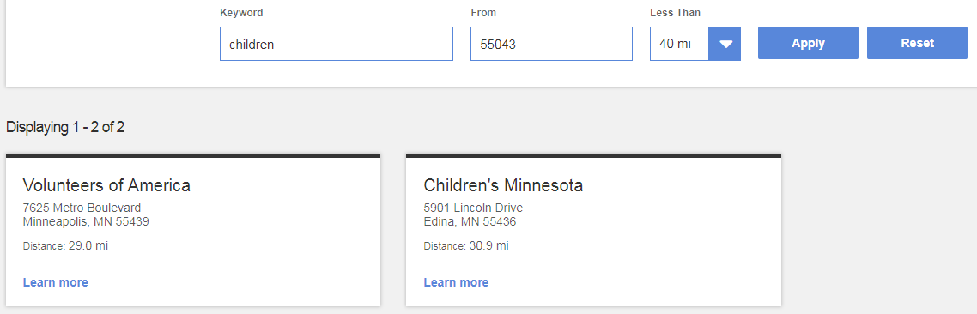
- Search results will be displayed in order of relevance to the keyword or distance from your location.
- Under the desired employer, click the “Learn More” link to view the description, location, and contact information.

