# Staff or Partner Account Dashboard

1. Open one of the recommended web browsers on your computer or mobile device.*
   * Apple Safari
   * Google Chrome
   * Microsoft Edge
   * Mozilla Firefox
2. Enter [www.careerforcemn.com](http://www.careerforcemn.com) in the browser address (URL) bar.
3. From the top menu, click the “Log in” link (if you don’t have an account yet, click “Sign Up” and follow the instructions to create an account.
4. On the Log In page, enter the username you created in the “Username” field. If you forgot it, click the “Forgot Username” link and follow the instructions.
5. Enter the password you created in the “Password” field. If you forgot your password, click the “Forgot Password” link and follow the instructions.
6. Click the “Submit” button.

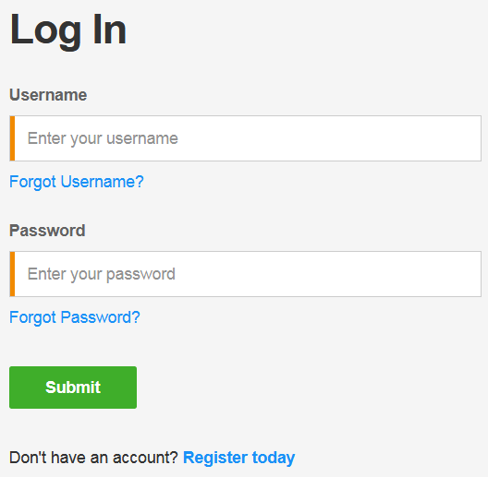

## Tell Us More About Your Services

The first time you log in to your account dashboard, you must select if you will be primarily using the site as a Career Seeker, Employer, or Partner or Staff.

1. Click “I am a Partner or Staff.”

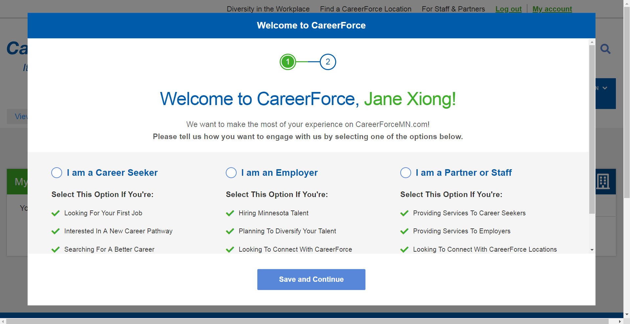

1. Click “Save and Continue.”
2. You will be asked for additional information, such as organization, location, contact information, services provided, and customer types. Most of this information is optional, but you should include the organization name and location to be added as a member to the organization’s group.
3. Click “I Agree To The Terms of Use” to open and read the terms in a new browser tab.
4. Close the Terms of Use browser tab and go back to the Welcome to CareerForce window.
5. Click the check box to agree to the terms of use.
6. Leave the box checked next to “Join CareerForce.”
7. Click “Save” to close the Welcome to CareerForce window and go to your account dashboard. Your account dashboard will only show career seeker tabs until your partner or staff account is approved by system administrators (please allow up to two business days for approval).

## Tabs

* Dashboard – Default view
* My Profile – Account information, including Name, Password, Email address, and Username
* My Staff/Partner Profile – Contact information and optional questions about services you provide
* My Goals & Experience – Career exploration tools and labor market information for career seekers
* My Labor Market – Labor market and occupational information for employers

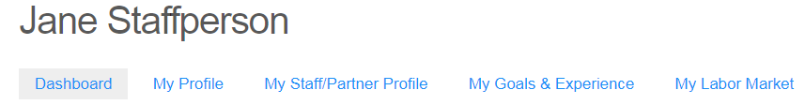

## CareerForce Location

If you selected a location when setting up your account, the closest CareerForce Location will show on your account dashboard and base search results on this location. To change the saved location:

1. Click the drop down arrow.
2. Enter a city or zip code in the field.
3. Click on the matching suggested location.
4. Click the “Select” button.

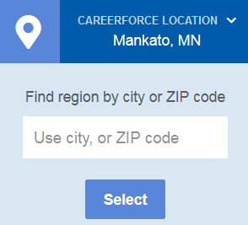

## My Favorites

You can save a link to most CareerForceMN.com pages in the My Favorites area of your account dashboard.

1. Log in to CareerForceMN.com.
2. Find a page that you want to save a link to.
3. Under the page title, find and click the “Add to favorites” link.

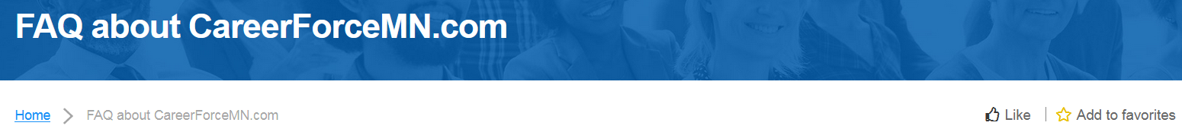

1. The link will change to “Remove from favorites.”
2. Scroll up to the top menu and click the “My Account” link.
3. On your account dashboard, find the “My Favorites” section.
4. Find the link to the page that you just added to your favorites.

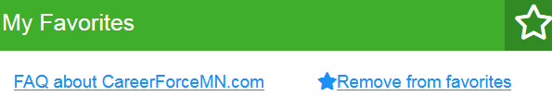

1. If you want to remove the link from your favorites, click “Remove from favorites.”
2. Refresh the page to make sure the link is removed from your favorites.

## My Connections

A CareerForce Connection is a message from a user to a CareerForce Location or Partner organization. Staff or Partner users who are assigned to respond to a Connection message will receive an email with a link to manage the message; the link to message will also appear in this section of their dashboard.

1. If your group manager assigns you a connection, you will receive an email with a link to open the connection in a web browser.

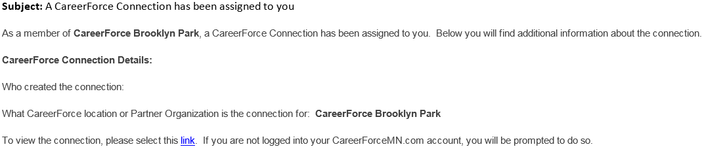

1. Click the link (or copy and paste the link into a supported browser).
2. If you are not logged in to CareerForceMN.com, you will be prompted to do so.
3. On the connection page, scroll down to the “Notes” section to read the message.
4. Respond to the message according to the requestor’s preferred contact method of email or phone. Messages cannot be responded to directly from CareerForceMN.com.
5. Click the “Status” drop down menu to update the status. Select “Pending” if you have left a message for the requestor or are otherwise working on the request. Select “Closed” if you have completed the request and the requestor has the information they need.
6. Click the check box next to “Notify Owner” if the requestor would like to receive an email about the status update.
7. Click the “Save” button to close the connection page.

## My Sent Connections

Partners or staff can send a CareerForce Connection on behalf of a customer, though it is recommended that customers create their own Connect With Us messages when possible.

1. Log in to CareerForceMN.com.
2. From the “My Sent Connections” section, click the “Create CareerForce connection” link.

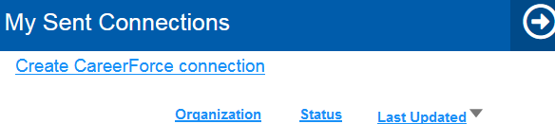

1. Click on the “Organization” drop-down menu and start to enter the name of the Location or Partner you want to contact.
2. From the suggested matches, click to select the name of the organization.
3. In the “Owner” field, enter the username of the customer. If the customer does not have a username, enter your own and make a note of this in the “Notes” field.
4. Leave the “Status” field as “Open.”
5. In the “Notes” field, enter the name, username (if applicable), detailed message, contact information, and preferred method of contact for the customer.

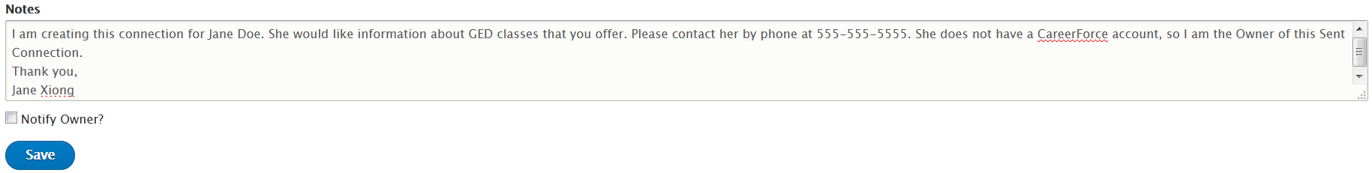

1. Check the box next to “Notify Owner” if the customer has an account and they would like to receive an email verifying this connection.
2. Click “Save.”
3. A “Connection has been successfully created” message will display.
4. If the customer has a username and you have selected it for the “Owner,” the customer can track the connection status on their account dashboard.

## My Organizations

Partners or staff affiliated with a Location and/or Partner can be added to their organization’s group. They can be a member of one than one group if they serve multiple Locations or Partners.

1. To be added to an organization’s group, first create your CareerForceMN.com account.
2. After your partner or staff account is approved, email your username to your group manager(s).
3. Once the group manager has added you to the organization’s group, a link to that organization’s page will show under the “My Organizations” (formerly “My Groups) section of your account dashboard.

## My Favorite Organizations

You can save a link to CareerForce Location and Partner pages in the My Favorite Organizations area (formerly My Favorite Groups) of your account dashboard.

1. Log in to CareerForcemn.com
2. Click “Find a CareerForce Location” from the top menu or “Meet Our Partners” from the bottom menu.
3. In the “From” field, enter a city or zip code and click on a suggested match.
4. Click the “Less Than” menu and select a mile radius.
5. Click “Apply.”
6. From the results list, click the “Learn More” link under the name of the desired CareerForce Location or Partner.
7. Under the Location or Partner description, find and click the “Add to favorites” link.
8. The link will change to “Remove from favorites.”
9. Scroll up to the top menu and click the “My Account” link.
10. On your account dashboard, find the “My Favorite Organizations” section.
11. Find the link to the page that you just added to your favorite organizations.

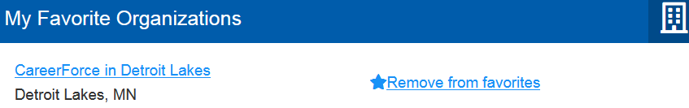

1. If you want to remove the link from your favorites, click “Remove from favorites.”
2. Refresh the page to make sure the link is removed from your favorites.