My Labor Market

Log In
- Open a recommended web browser* on your computer or mobile device.
  - Apple Safari
  - Google Chrome
  - Microsoft Edge
  - Mozilla Firefox
- Enter www.careerforcemn.com in the browser address (URL) bar.
- From the top menu, click the “Log in” link.
- Enter your username in the “Username” field. If you forgot your username, click the “Forgot Username” link and follow the instructions.
- Enter your password in the “Password” field. If you forgot your password, click the “Forgot Password” link and follow the instructions.
- Click “Submit” to open your account Dashboard.

My Labor Market
- Only Staff/Partner and Employer users have a “My Labor Market” link on their Dashboard.
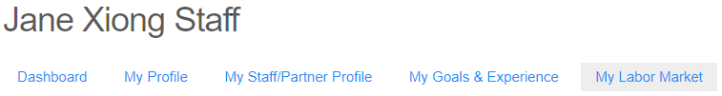
- Click the “My Labor Market” link to open the My Labor Market page, which displays Statewide Economic Highlights with Labor Force, Unemployment Rate, and Industry Trends.
- The CareerForce Locations Near You section shows the two closest CareerForce Locations to the user’s selected city, county or ZIP code, and a “Find More Locations” link to the CareerForce Location Search.
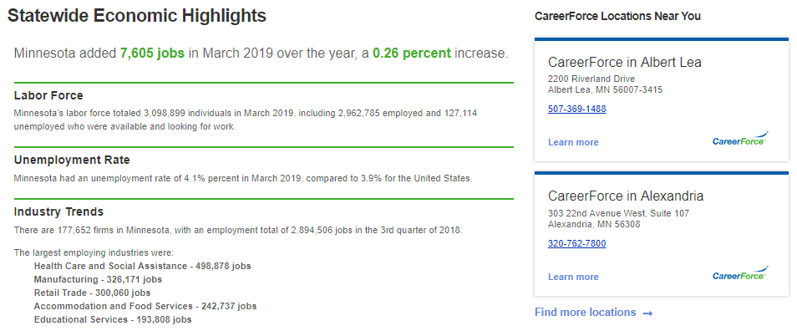

Add a Region
- The user’s regional Labor Force, Unemployment Rate, Industry Trends, Industry Sector Partnerships, and Regional News will be displayed, based upon the user’s selected account location.
- To remove a region, click the “X” in the upper right corner of that section.
- To add a region, click “+ Add a region.”
- On the “Add a Region” pop-up box, click a region radio button to select it.
- Click the “Add region” link to display the new region on the page.
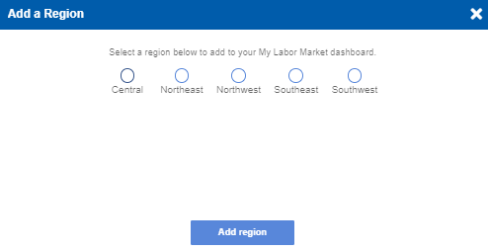

Now Hiring
- In the “Now Hiring” section, enter an occupational title to view suggested matches.
- Click on a suggested matching title to fill the text field.
- Click on the “Add Career” button.
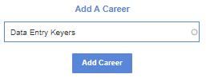
- A pop-up box will display the “Added new career to your hiring careers!” message. Click “OK” to close it.
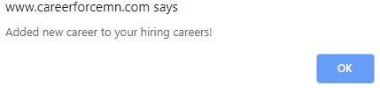
- Click “Learn more” under the added career to view occupational details.
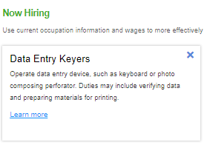
- Use occupational details, including Education, Demand, Wages, Cost of Living, and Daily Work Activities, to help with talent recruitment, development, and retention for your organization.

