# Career Seeker Account Dashboard

1. Open one of the recommended web browsers on your computer or mobile device.*
   * Apple Safari
   * Google Chrome
   * Microsoft Edge
   * Mozilla Firefox
2. Enter [www.careerforcemn.com](http://www.careerforcemn.com/) in the browser address (URL) bar.
3. From the top menu, click the “Log in” link (if you don’t have an account yet, click “Sign Up” and follow the instructions to create an account.
4. On the Log In page, enter the username you created in the “Username” field. If you forgot it, click the “Forgot Username” link and follow the instructions.
5. Enter the password you created in the “Password” field. If you forgot your password, click the “Forgot Password” link and follow the instructions.
6. Click the “Submit” button.

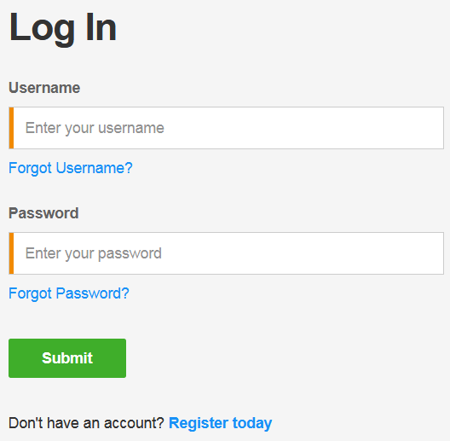

## Tell Us More about Yourself

The first time you log in to your account dashboard, you must select if you will be primarily using the site as a Career Seeker, Employer, or Partner or Staff.

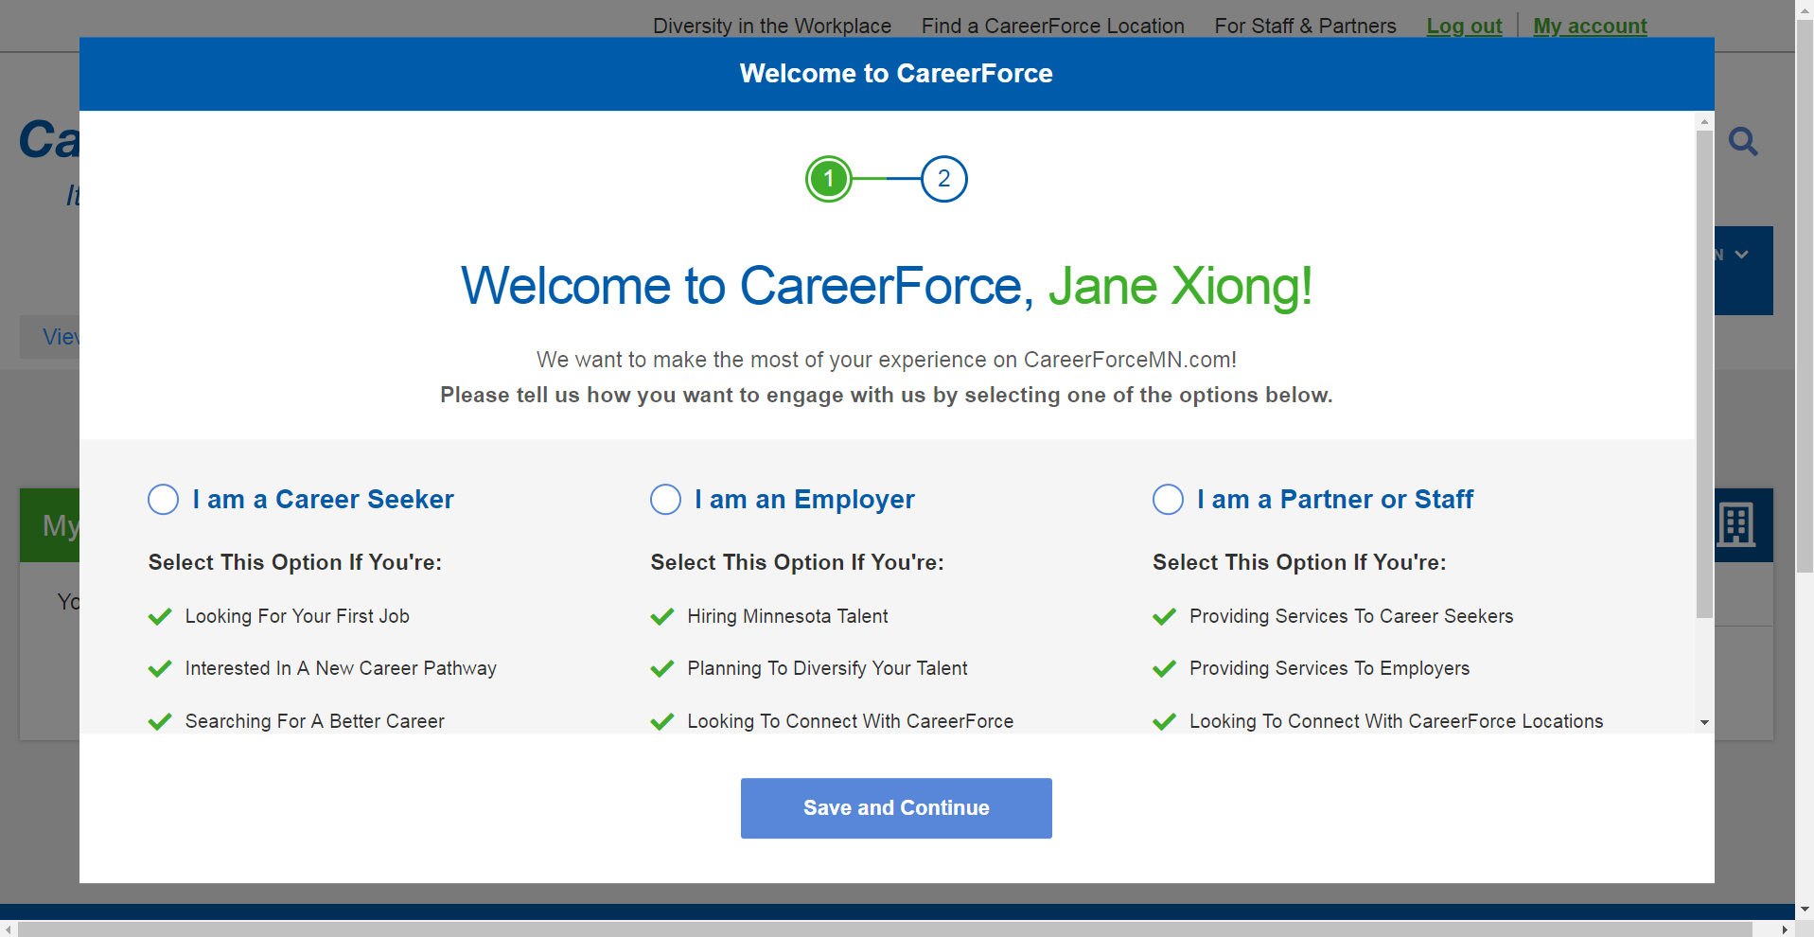

Career seekers will be prompted to answer optional demographic questions. You do not need to give us this information by law, but it helps serve you better. The information may be used to determine if you’re eligible for special assistance, to provide personalized resources, and to evaluate our performance. Click the “Save” button to close the questions and view your account dashboard.

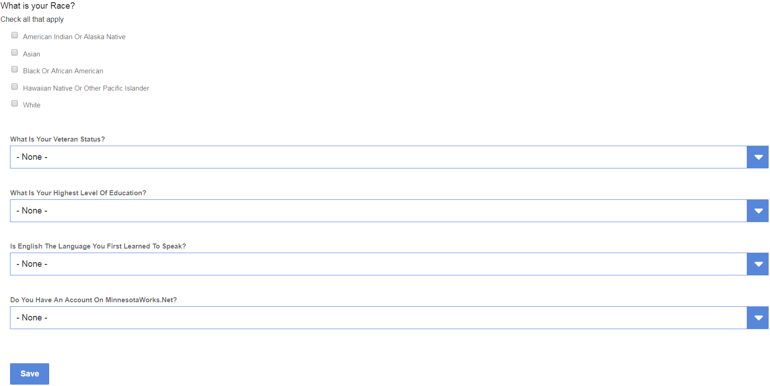

## My Location

If you selected a location when setting up your account, the closest My Location will show on your account dashboard and base search results on this location. To change the saved location:

1. Click the drop down arrow.
2. Enter a city or zip code in the field.
3. Click on the matching suggested location.
4. Click the “Select” button.

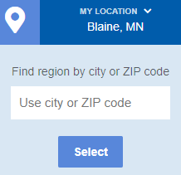

## My Favorites

You can save a link to most CareerForceMN.com pages in the My Favorites area of your account dashboard.

1. Log in to CareerForceMN.com.
2. Find a page that you want to save a link to.
3. Under the page title, find and click the “Add to favorites” link.

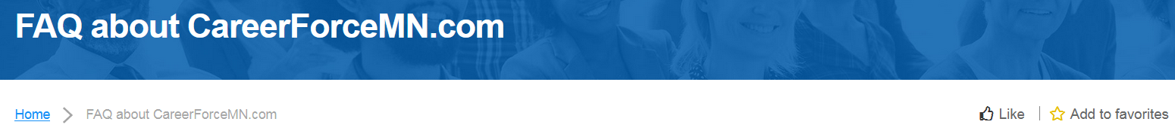

1. The link will change to “Remove from favorites.”
2. Scroll up to the top menu and click the “My Account” link.
3. On your account dashboard, find the “My Favorites” section.
4. Find the link to the page that you just added to your favorites.

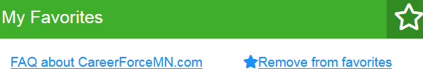

1. If you want to remove the link from your favorites, click “Remove from favorites.”
2. Refresh the page to make sure the link is removed from your favorites.

## My Connections

A CareerForce Connection is a message that can be sent to a CareerForce Location or Partner and tracked on your account dashboard.

1. Log in to CareerForcemn.com
2. Click “Find a CareerForce Location” from the top menu or “Meet Our Partners” from the bottom menu.
3. In the “From” field, enter a city or zip code and click on a suggested match.
4. Click the “Less Than” menu and select a mile radius.
5. Click “Apply.”
6. From the results list, click the “Learn More” link under the name of the desired CareerForce Location or Partner.
7. In the contact information area, click the “Connect With Us” button.
8. In the pop-up box, enter your message in the “Notes” field, including a detailed message or question, your contact information, and your preferred contact method.
9. “Click Save.”
10. Review the “Connection created” message and click the X to close the pop-up box.
11. Scroll up to the top menu and click the “My Account” link.
12. Under the “My Connections” section, find the connection you just created, which includes the organization you contacted, status, date, time and “Actions” options.

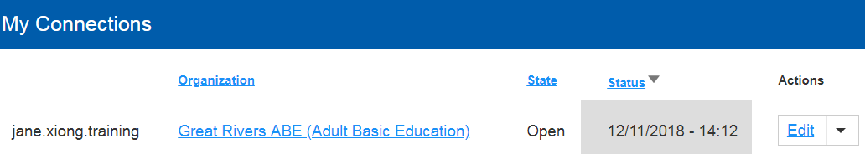

1. To view the connection, click “Edit” from the Actions menu.
2. If you want to delete the connection, click the “Actions” menu and select “Delete.”
3. Click “Delete” to confirm deletion and remove it from your connections.

## My Favorite Organizations

You can save a link to CareerForce Location and Partner pages in the My Favorite Organizations area of your account dashboard.

1. Log in to CareerForcemn.com
2. Click “Find a CareerForce Location” from the top menu or “Meet Our Partners” from the bottom menu.
3. In the “From” field, enter a city or zip code and click on a suggested match.
4. Click the “Less Than” menu and select a mile radius.
5. Click “Apply.”
6. From the results list, click the “Learn More” link under the name of the desired CareerForce Location or Partner.
7. Under the Location or Partner description, find and click the “Add to favorites” link.
8. The link will change to “Remove from favorites.”
9. Scroll up to the top menu and click the “My Account” link.
10. On your account dashboard, find the “My Favorite Organizations” section.
11. Find the link to the page that you just added to your favorite organizations.
12. If you want to remove the link from your favorites, click “Remove from favorites.”
13. Refresh the page to make sure the link is removed from your favorites.

