# Group Management

Table of Contents

Use a Recommended Web Browser* 1

Sign Up for an Account 1

Go to Your Organization Page 3

Add an Existing User to Your Group 4

Add a New User to CareerForceMN.com 5

Edit or Remove a Group Member 6

Assign a CareerForce Connection to a Group Member 6

Update a CareerForce Connection Status 7

Transfer a CareerForce Connection 7

A group is a CareerForce Location, Partner or employer organization. A group manager is someone affiliated with the organization who will manage organization members and pages on CareerForceMN.com. The group manager will also receive CareerForce Connections, messages from CareerForceMN.com users, and assign them to organization members for timely and appropriate responses.

## Use a Recommended Web Browser*

* Apple Safari
* Google Chrome
* Microsoft Edge
* Mozilla Firefox

## Sign Up for an Account

Before you can be a group manager, you must create a CareerForceMN.com account.

1. Open a recommended browser to [www.careerforcemn.com](http://www.careerforcemn.com)
2. On the home page, click “Sign Up” in the upper right corner of the screen.



1. In the “Name” field, enter your first and last name.
2. In the “Email Address” field, enter your work email address.
3. In the “Username” field, enter a username that is easy for you to remember, such as:
   * A combination of your first and last name
   * All or the first part of your work email address
4. The “City,” “State” and “Zip Code” fields are optional, but entering them will give you location-specific search results.
5. Click the “Data Privacy Notice” link to open and read the data privacy information in a new tab.
6. Close the Data Privacy tab to return to the sign up page.
7. Click to check the box next to the Data Privacy statement.
8. Click the box next to “I’m not a robot” and follow the CAPTCHA instructions.
9. Click “Sign up.”

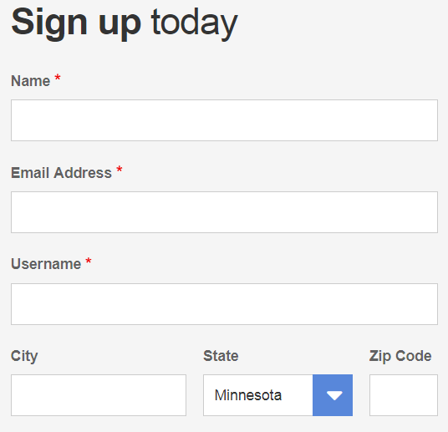

1. A message will display saying that your registration is successful and that you will receive an email message to activate your account.



1. Check your email account for a message from CareerForce.

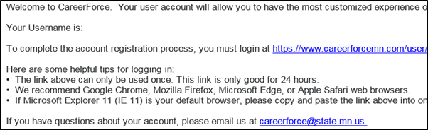

1. Copy and paste the one-time link into a recommended web browser.
2. On the new page, click the “Log in” button.

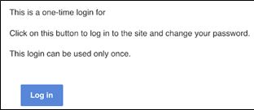

1. Enter a new Password and re-enter it in the “Confirm password” field. The password requirements will disappear as you complete them.

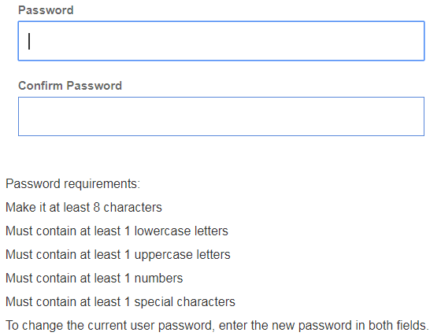

1. Click “Save” and a message will show that is it saved.

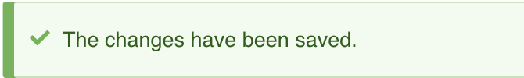

1. Email [careerforce@state.mn.us](mailto:careerforce@state.mn.us) to let us know that you are the designated group manager for your organization and what your username is.
2. CareerForceMN.com staff will email to let you know you are now the group manager and will include group management instructions.

## Go to Your Organization Page

1. Open a recommended web browser to [www.careerforcemn.com](http://www.careerforcemn.com).
2. Click the “Log in” link in the upper right corner.
3. Click the “My account” link to open your account dashboard.
4. Under the “My Organizations” section, click the link for organization.
5. Find the group management links at the top of your organization page.

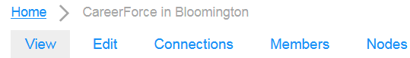

## Add an Existing User to Your Group

1. Ask the user for their CareerForceMN.com username. If they don’t have an account yet, they will need to create one first.
2. To add a new group member, click “+ Add member.”

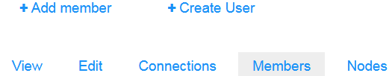

1. In the “Username” field, enter the username of the person you want to add to your group. As you start to enter letters, suggested usernames will appear.
2. Click to select the desired username.
3. If the user is a group member, leave the “Roles” boxes unchecked.
4. If the user is another group manager, check the box next to the “CareerForce Group & Content Management” role.
5. If the user is a content manager (cannot add group members), check the box next to “CareerForce Content Management.”
6. Click “Save.”

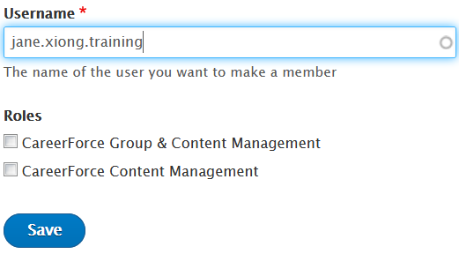

1. If the group member you added is a group manager, click “Edit” to view the settings for your group.
2. Scroll down to the “Connection Review Emails” section.
3. Enter the user’s email address (separate multiple email addresses by a comma and space) so they get email notifications when new CareerForce Connections come in for your organization.
4. Click “Save.”

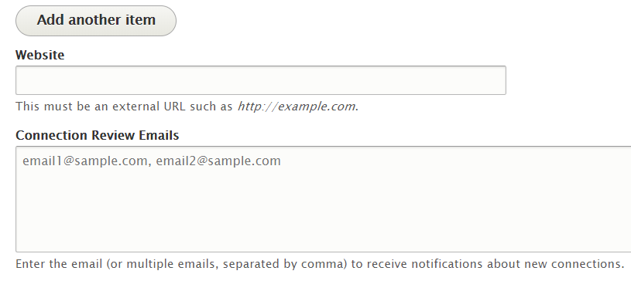

## Add a New User to CareerForceMN.com

To add a new user (someone without a CareerForceMN.com account) to your group, first you have to create an account for them. This may be helpful if you want to standardize all usernames for your group members.

1. On your organization page, click “Members.”
2. Click “+ Create User.”



1. In the “Name” field, enter the user’s first and last name.
2. In the “Email Address” field, enter the user’s work email address.
3. In the “Username” field, enter a standardized username, such as the user’s work email addresses or a version of their first and last name.

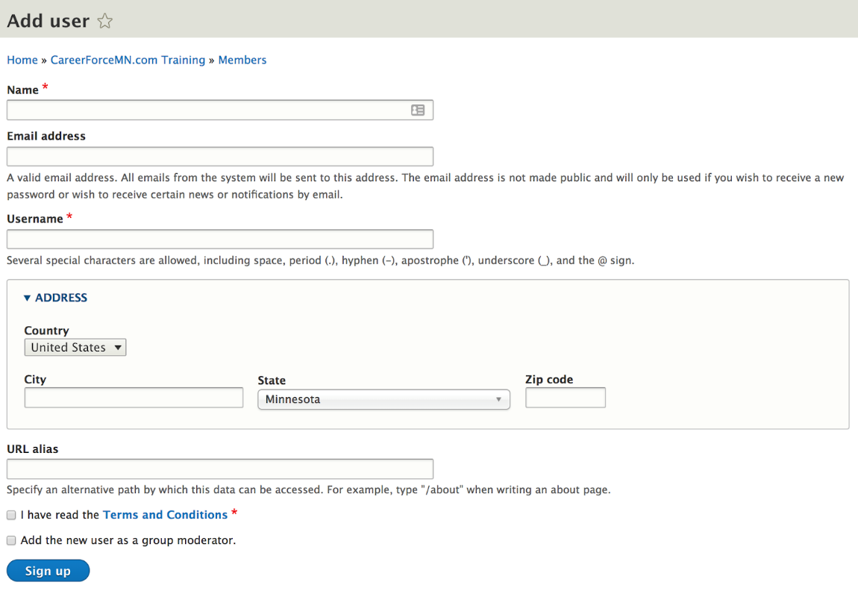

1. The Address section is optional.
2. Click to check the box next to “Data Privacy Notice,” but make sure you verify that the user reads the Data Privacy Notice before using the site.
3. If the user will be a group or content manager, check the box next to “Add the new user as a group moderator.”
4. Click the box next to “I’m not a robot” and follow the CAPTCHA instructions.
5. Click “Sign up.”
6. Let the user know that you have created an account for them and that they will receive an email message from CareerForce with login instructions.

## Edit or Remove a Group Member

1. On your organization page, click the “Members” link.
2. From the list of group members, find the user you want to edit or remove from your group.
3. Click the drop-down menu under the “Operations” column.
4. Select “Edit member” if you want to change or add a role in your group and click “Save.”
5. Select “Remove member” if you want to remove them from your group and click “Delete” to confirm (this will not remove them from CareerForceMN.com but will remove them from your organization).

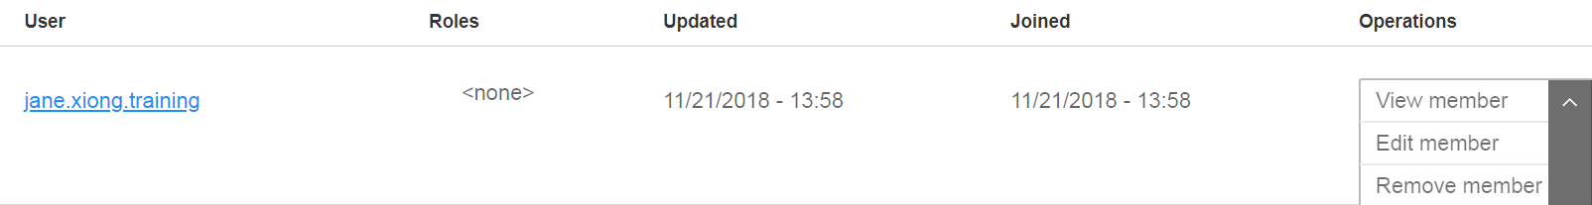

## Assign a CareerForce Connection to a Group Member

1. On your organization page, click the “Connections” link.
2. By default, the results are filtered by “Open” status.
3. Find an open connection and select “Edit” from the “Actions” drop-down menu.
4. Review the message in the “Notes” field.
5. The “Service” will be auto-filled if the connection was created from a service card of the site.
6. Click the “Assigned To” drop-down menu and click to select the appropriate group member to respond to the message.
7. Click the “Status” drop-down menu and select “Assigned.”
8. Click the check box next to “Notify Owner” if you want the customer to receive a status update email.

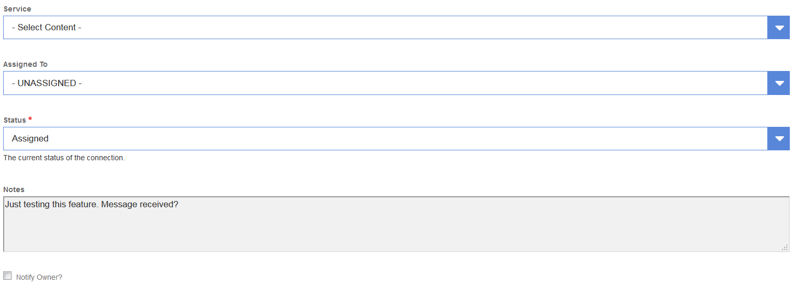

1. Click “Save.”
2. The assigned group member will receive an email with a link to the Connection.

## Update a CareerForce Connection Status

1. On your organization page, click the “Connections” link. (Group members access assigned Connections from their “My Connections” section on their account dashboard.)
2. The default “State” is “open.” To display all connections, delete “open” and click the “Apply” button.
3. Find the connection you want and click “Edit” from the “Actions” drop-down menu.
4. Click the “Status” drop-down menu and select one of the following statuses:
   * “Open” means unassigned.
   * “Assigned” means you have assigned it.
   * “Pending” means the assigned group member is working on it or the user has not responded.
   * “Closed” means the assigned group member has completed the connection request.
   * “Archived” means that a closed connection can be removed from the list of your organization’s connections (it is not deleted from the system and can be retrieved by emailing [CareerForce@state.mn.us](mailto:CareerForce@state.mn.us), if needed).

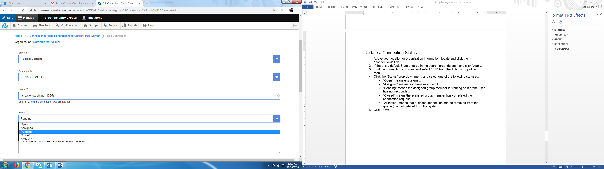

1. Click the check box next to “Notify Owner” if you want the customer to receive a status update email.
2. Click “Save.”

## Transfer a CareerForce Connection

1. On your organization page, click the “Connections” link. (Group members access assigned Connections from their “My Connections” section on their account dashboard.)
2. The default “State” is “open.” To display all connections, delete “open” and click the “Apply” button.
3. Find the connection you want and select “Transfer” from the “Actions” drop-down menu.
4. Click the “Organization” drop-down menu and select the CareerForce Location or Proud Partner you want to transfer the connection to.
5. If you know the group member you want to assign the connection to, click the “Assigned To” drop-down menu to select them, if listed. If you don’t select a specific group member, it will go to the group manager.
6. Click “Transfer.”