# Career Search

1. Open one of the recommended web browsers on your computer or mobile device.*
   * Apple Safari
   * Google Chrome
   * Microsoft Edge
   * Mozilla Firefox
2. Enter [www.careerforcemn.com](http://www.careerforcemn.com) in the browser address (URL) bar.
3. On the CareerForceMN.com home page, scroll down to the Career Search section.
4. In the search field, enter a job title, employer, skill or other keyword.
5. Enter the “Enter a location” field, enter a city or zip code. This is optional, but leaving the location empty will return up to 500 results.



1. Click “Search jobs.”
2. Browse the job search results, which are sorted in order of most recently posted.
3. Click the “View” link under any result to open the job description in a new browser tab or window. The job description may be from the employer’s website or MinnesotaWorks.net, depending upon where the job was posted.

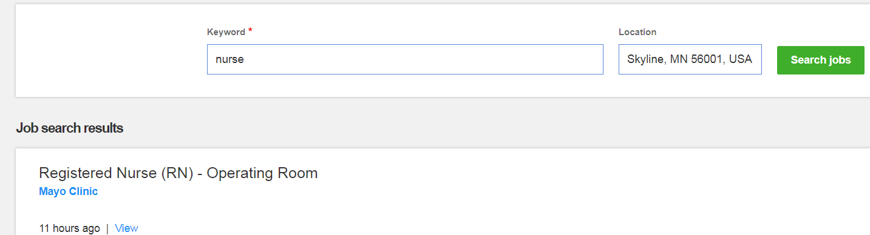

1. Follow the instructions to apply for the job on the employer’s website or MinnesotaWorks.net. You may need to create or log into an account on that site in order to apply for a job.