CareerForceMN.com Skills & Experience Tools

Log In
- Open a recommended web browser* on your computer or mobile device.
  - Apple Safari
  - Google Chrome
  - Microsoft Edge
  - Mozilla Firefox
- Enter www.careerforcemn.com in the browser address (URL) bar.
- From the top menu, click the “Log in” link.
- Enter your username in the “Username” field. If you forgot your username, click the “Forgot Username” link and follow the instructions.
- Enter your password in the “Password” field. If you forgot your password, click the “Forgot Password” link and follow the instructions.
- Click “Submit.”
- Your account dashboard will open (except for the first time you log in, when you will be prompted to answer optional questions).
- Click the “Skills & Experience” link.
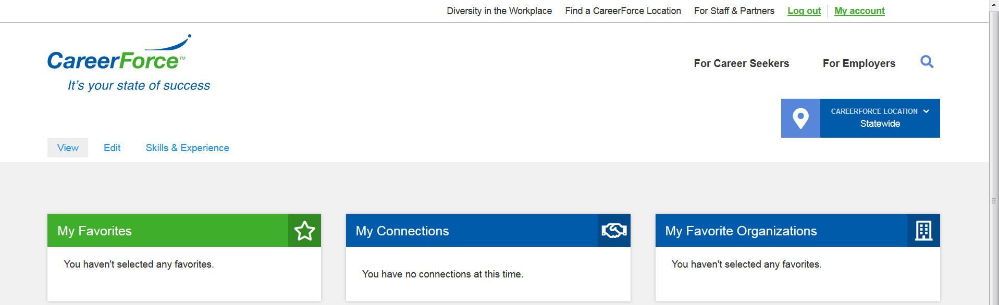

Search Skills
- Click the “Search skills” link to open the Skills Matcher.
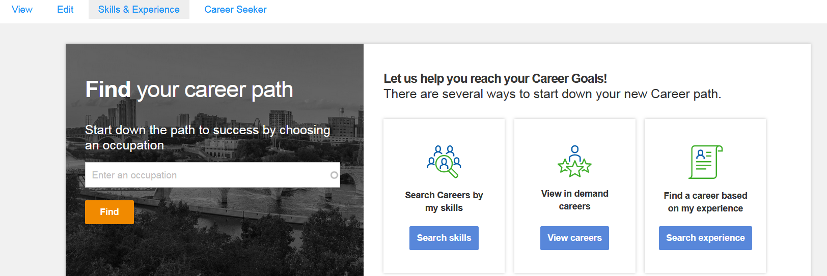
- For each skill listed, click the radio button that represents your skill level, either Beginner, Basic, Skilled, Advanced or Expert. There are examples for some levels to help you choose.
- Complete all ten questions on each page then click “Continue.”
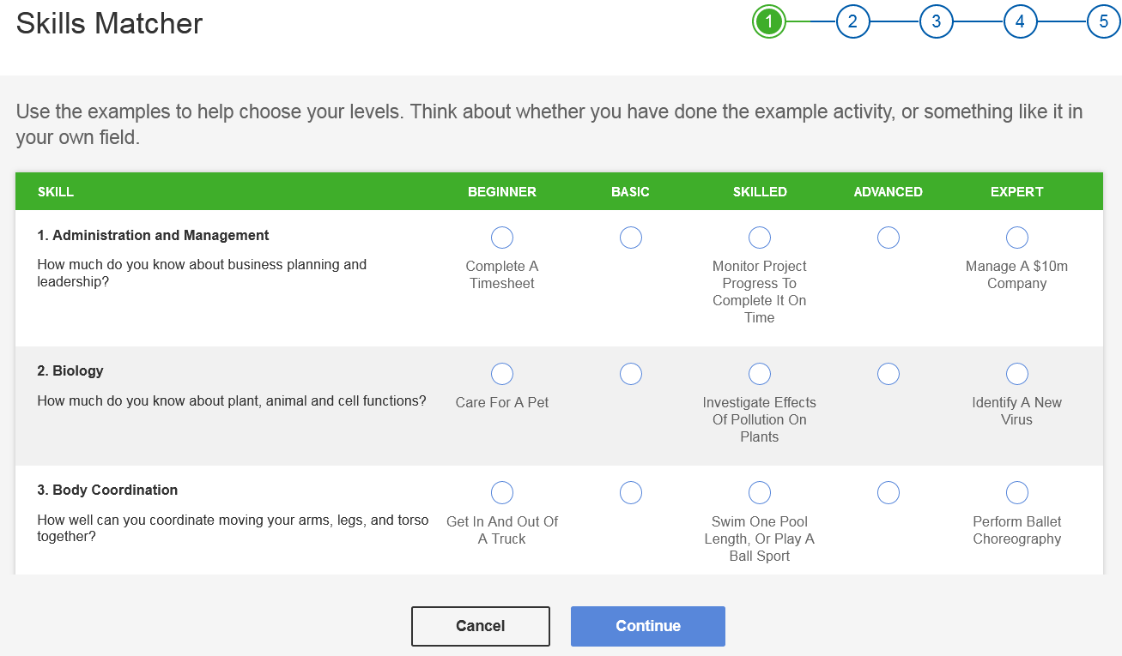
- Complete all five pages of questions then click “Submit.”
- From the Matching Careers results, click the check box in the row of the career you want to add to your career goals.
- Click “Submit” to add the career to your My Career Goals section.
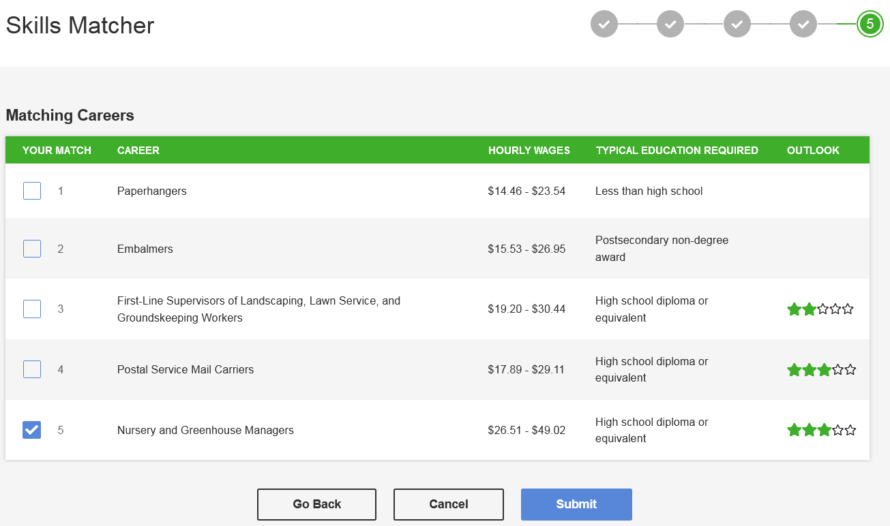
- Under My Career Goals, find the career you just added and click “Learn more” for information, including:
  - occupation description
  - similar career titles
  - education
  - regional demand
  - wages
  - cost of living
  - daily work activities
  - video
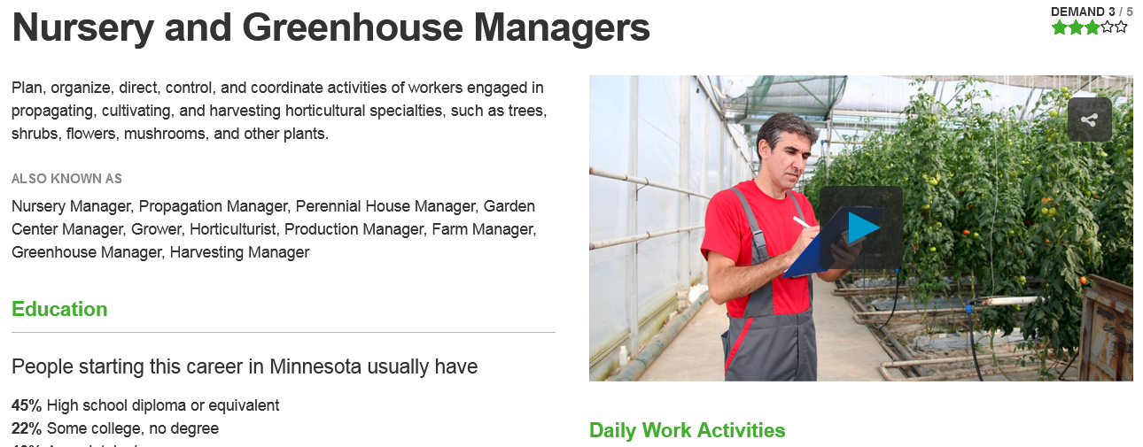

View Careers
- To view regional results for in demand careers, enter a city or zip code and click “Select.” If you don’t select a location, the default region will be Statewide.
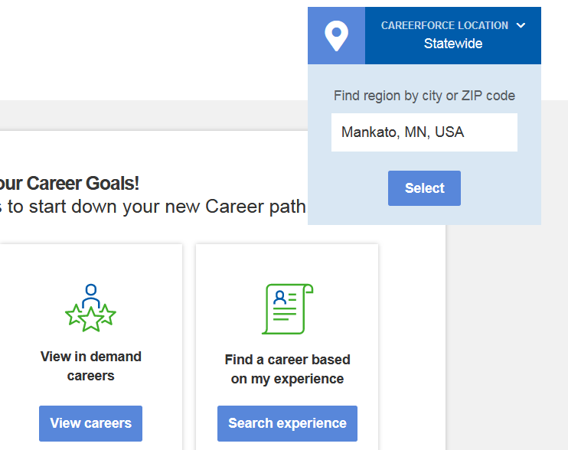
- Click the “View careers” link to view in demand careers.
- From the In Demand Careers results list, click the check box in the row of the career you want to add to your career goals.
- Click “Add to Career Goals.”
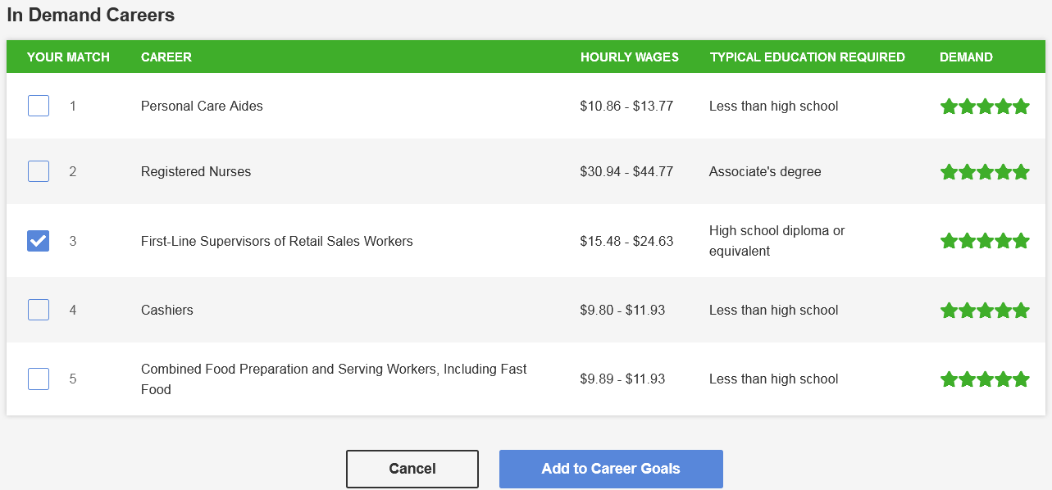
- Under My Career Goals, find the career you just added and click “Learn more” for occupation information.

Search Experience
- Click the “Search experience” link to add past occupations and view similar careers.
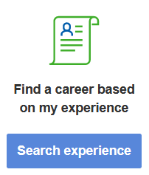
- The page will scroll down to the My Work Experience section.
- In the “Add Work Experience” field, enter a past job title.
- As you type, matching occupations will be suggested. Click a matching occupation.
- Click the plus sign to add that occupation to your work experience.
- Click “OK” to close the pop-up that verifies the work experience has been added.
- The occupation experience will now display under My Work Experience. Under Similar Jobs, view some careers suggestions that match your experience.
- Under any of the results, click “Learn more” for occupation information.
- Under any of the results, click “Set as Career Goal” to add it to your My Career Goals section.
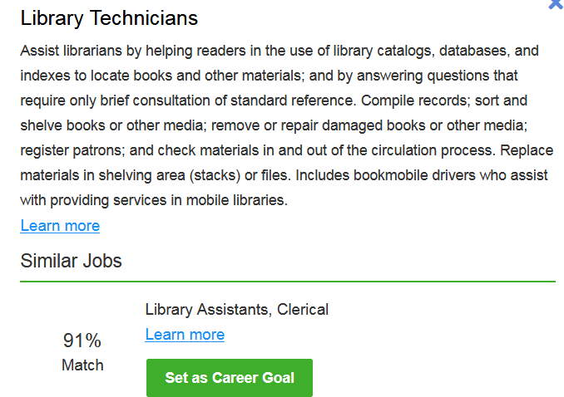
- Click “OK” to close the pop-up that verifies the career goals has been added.
- Under My Career Goals, find the career you just added and click “Learn more” for occupation information.
